Press Release of the First Meeting of ASEAN Intergovernmental Commission on Human Rights on the ASEAN Human Rights Declaration
Siem Reap, Cambodia, 8 – 9 January 2012

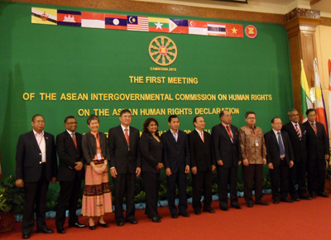
The ASEAN Intergovernmental Commission on Human Rights (AICHR) convened its First Meeting on the ASEAN Human Rights Declaration (AHRD) from 08 - 09 January 2012 in Siem Reap, Cambodia. This was the first meeting under the Cambodian Chairmanship and chaired by H.E. Om Yentieng, Senior Minister and President of the Cambodian Human Rights Committee (CHRC), the Cambodian Representative, the Chair of AICHR, in 2012.
The Chair's Statement of the 19th ASEAN Summit noted the task given by the Foreign Ministers to AICHR to finalize the drafting of the ASEAN Human Rights Declaration and to submit a Progress Report to the AMM Retreat in January 2012. Pursuant to this task, the Meeting held discussion and adopted the Progress Report on the AHRD to the ASEAN Foreign Ministers. In the Progress Report, AICHR reaffirmed its commitment and determination to finalize the AHRD in 2012 and set out the way it will achieve that aim. AICHR also appreciated the hard work of the Drafting Group to produce the basic draft of the AHRD and their Final Report.
The Meeting also discussed its tentative 2012 calendar for deliberation on the AHRD. The 2012 calendar for AICHR sets out the agreed dates and venues for AICHR meetings on the AHRD and the three regular meetings of AICHR.
The Meeting expressed appreciation to the Host for the hospitality and excellent arrangements for the Meeting.
The Second Meeting of AICHR on the AHRD will be held from 17 – 19 February 2012 at the ASEAN Secretariat in Jakarta, Indonesia.

