Press Release of the Seventh Meeting of the ASEAN Intergovernmental Commission in Human Rights (AICHR)
Bali, 2 December 2011

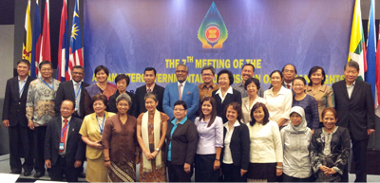
The Seventh ASEAN Intergovernmental Commission on Human Rights (AICHR) Meeting was held from 28 November – 1 December 2011 in Bali, Indonesia. The Meeting was the fourth and the last meeting of AICHR in 2011 chaired by the Representative of Indonesia to AICHR.
The Meeting welcomed the new Representative of Brunei Darussalam to AICHR, H.E. Pehin Dato Haji Ahmad Jumat.
The Meeting discussed and finalized the AICHR Work Plan (2013-2015) as well as the AICHR’s Priority Programme 2012 and its budget. The Meeting also discussed and adopted the budget for the thematic study on Corporate Social Responsibility (CSR) and Human Rights, the draft Terms of Reference (TOR) on the thematic study of Right to Peace and approved in principle the concept paper on the two training programmes on human rights.
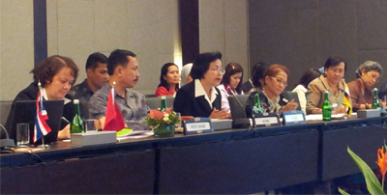
The Meeting took note of the results of the three seminars: “Towards Achieving Substantive Gender Equality” together with UN Women in Jakarta, the “ASEAN Conference/Workshop on Promoting Maternal Health: Responding to the UN Millennium Development Goal 5” with the Centre for Reproductive Rights and the United Nations Population Fund (UNFPA) in Manila, the “Regional Workshop on Statelessness and the Rights of Women and Children” with the United Nations High Commissioner for Refugees (UNHCR) in Manila, and discussed the possibility of taking concrete steps as a follow up to these seminars.
The Meeting invited the Chair of the Drafting Group on the ASEAN Human Rights Declaration and noted her report on the drafting progress. The meeting agreed to extend the mandate of the Drafting Group by arranging an additional meeting in January 2012.
During the course of the AICHR Meeting, AICHR Representatives also had an interface dialogue with H.E. Dr. Surin Pitsuwan, the Secretary-General of ASEAN. The Secretary-General highlighted the importance of AICHR, as an overarching human rights institution in ASEAN. He added that recognition and legitimacy is to be gained further by providing leadership, guidance and working together with the relevant stakeholders.
AICHR Representatives met for the first time with the ASEAN Commission on the Promotion and Protection of the Rights of Women and Children (ACWC) to discuss the alignment of ACWC in which ACWC acknowledged the mandate of AICHR as the overarching body on human rights in ASEAN. They exchanged views on the status of these two (2) Commissions based on the ASEAN Charter and their respective TORs. The meeting recognized the mandate of each Commission as stipulated in their respective TORs and will explore cooperation in accordance with the work plans of the two Commissions, for better coordination and collaboration. Both AICHR and ACWC agreed that this meeting will be the first of many between the two bodies.
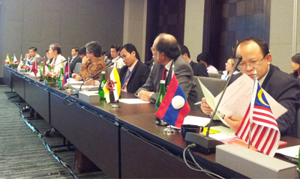
The meeting also welcomed H.E. Mdm. Navanethem Pillay, the United Nations (UN) High Commissioner for Human Rights, in an interface dialogue session. In her remarks, the High Commissioner stated that the creation of AICHR and ACWC is a positive development for the promotion and the protection of human rights in the region. The AICHR Representatives brought to the attention of Mdm. Pillay various issues including avenues of cooperation between AICHR and OHCHR. AICHR explained to the High Commissioner activities with regards to external relations and its interaction with the civil society. The High Commissioner expressed appreciation for the ongoing work of AICHR and that AICHR is already beginning its efforts to relate with civil society.
In relation to AICHR’s engagement with external parties, the meeting met with UNICEF East Asia and Pacific Regional Office. The meeting took note of UNICEF’s presentation concerning the Draft ASEAN – UNICEF Framework of Cooperation and preliminarily explored possible elements of cooperation between AICHR and UNICEF. The Framework of Cooperation, which is a rights-based approach, is going to be further studied by AICHR.
The AICHR Representatives expressed their high appreciation to the Representative of Indonesia, Mr. Rafendi Djamin, for his leadership and hard work as the Chair of AICHR and the tremendous support from the Government and the people of Indonesia for the warm hospitality given to the delegations.
The Eight (8th) ASEAN Intergovernmental Commission on Human Rights Meeting will be held on 6 – 10 March 2012 at the ASEAN Secretariat in Jakarta.

